1. **Problem Name:** Write a Java program to find the sum of all odd numbers in an array.

**Problem Code & Output:**

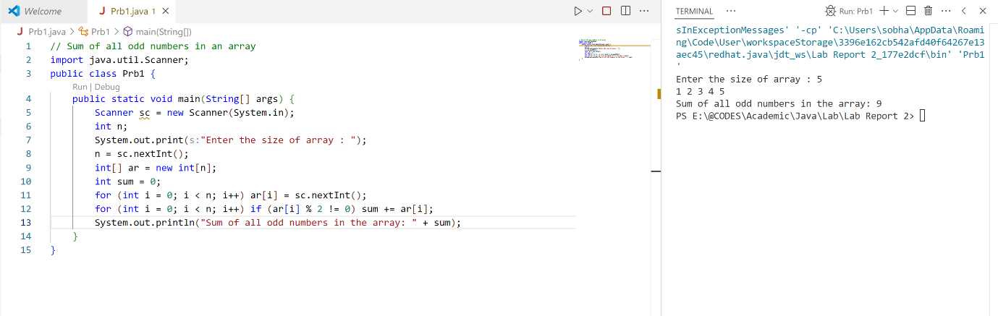

1. **Problem Name:** Write a Java program that takes two arrays as input, calculate the index wise sum of these arrays, and store the result in a third array.

**Problem Code & Output:**

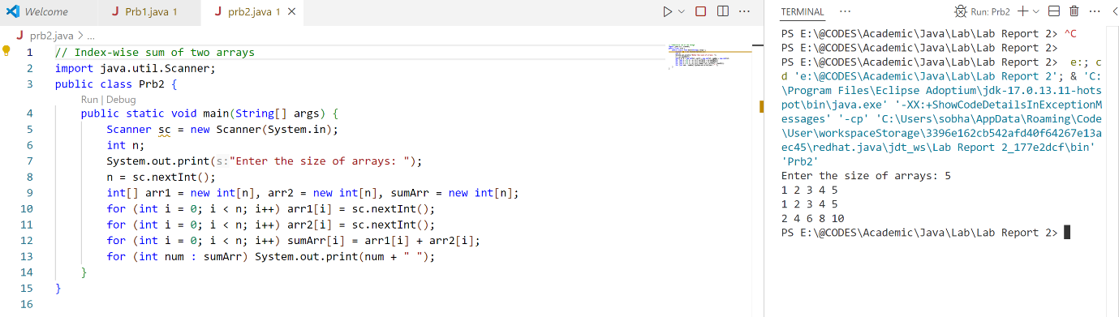

1. **Problem Name:** Write a Java program to search an element in an array.

**Problem Code & Output:**

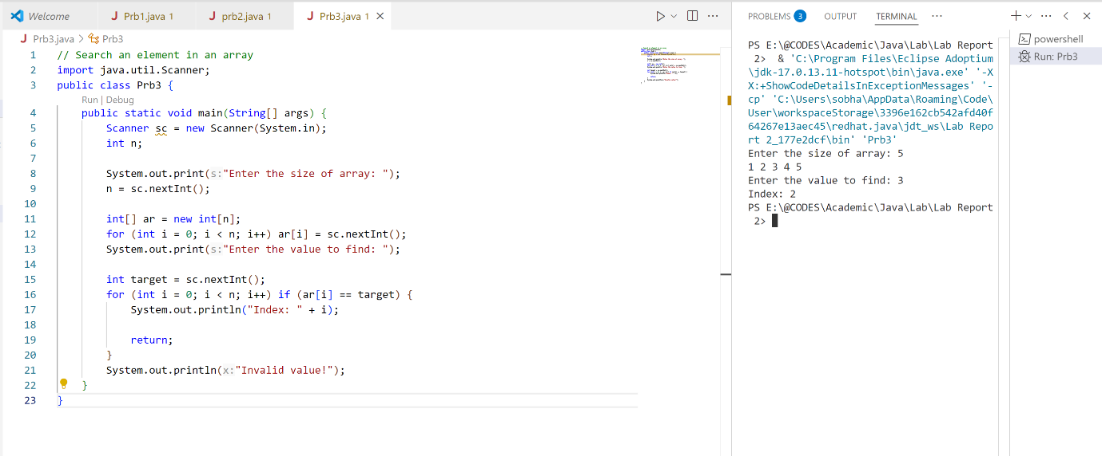

1. **Problem Name:** Write a Java program to reverse the elements in an array without using a second array.

**Problem Code & Output:**

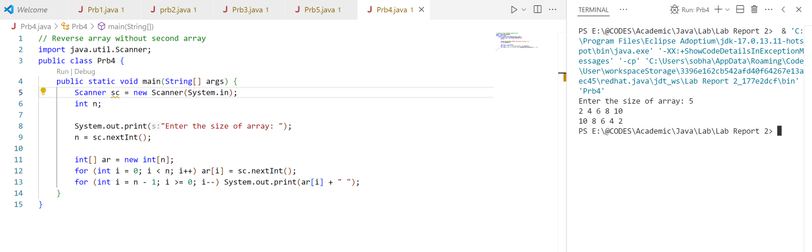

1. **Problem Name:** Write a Java program to find the second highest element of an array.

**Problem Code & Output:**

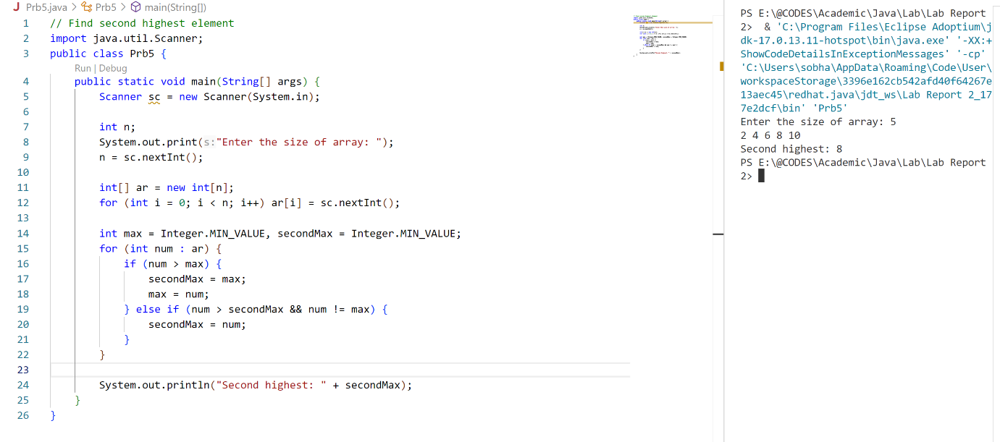

1. **Problem Name:** Write a Java program that calculates the average of an array, excluding the highest and lowest values in the array.

**Problem Code & Output:**

